1. Write SQL query that extracts the year, month, and day from the date attribute for the orders table. Display them as three separate attributes alongside the id attribute and the original date attribute (resulting in total of 5 attributes).
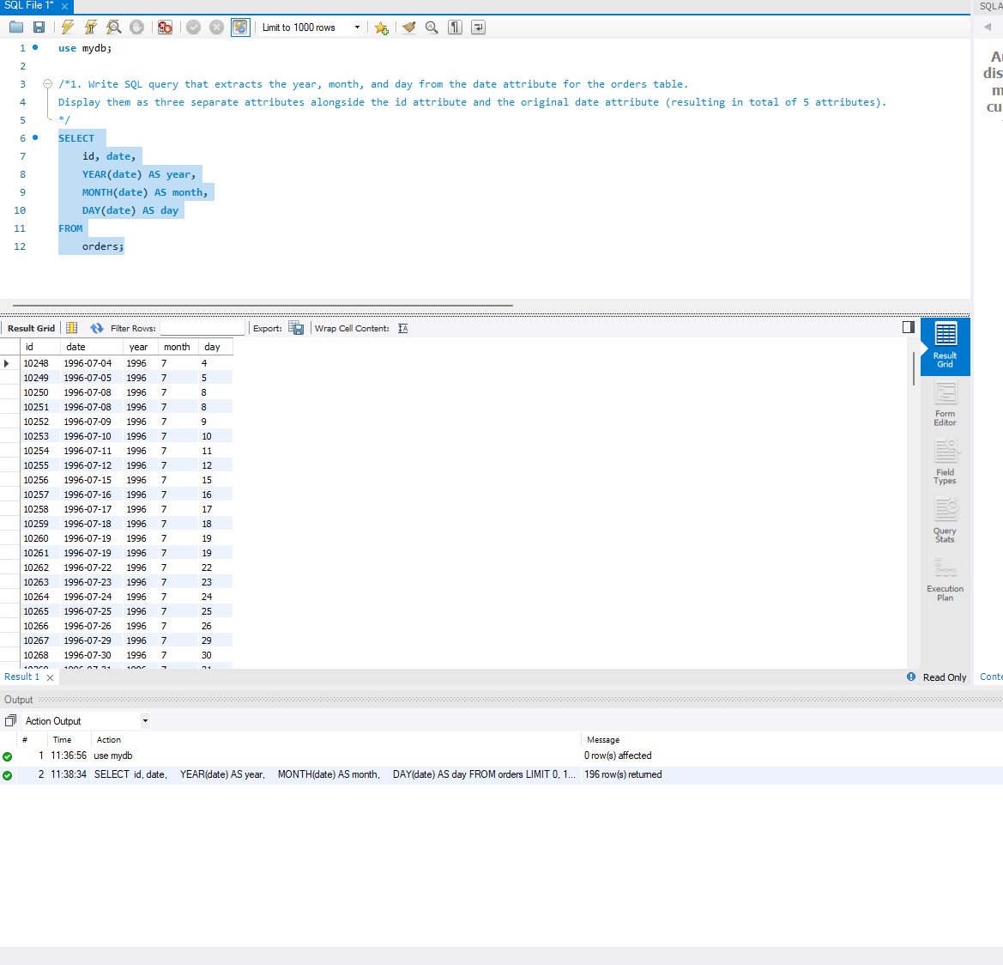
2. Write SQL query that adds one day to the date attribute for the orders table. Display the id attribute, the original date attribute, and the result of the addition on the screen.
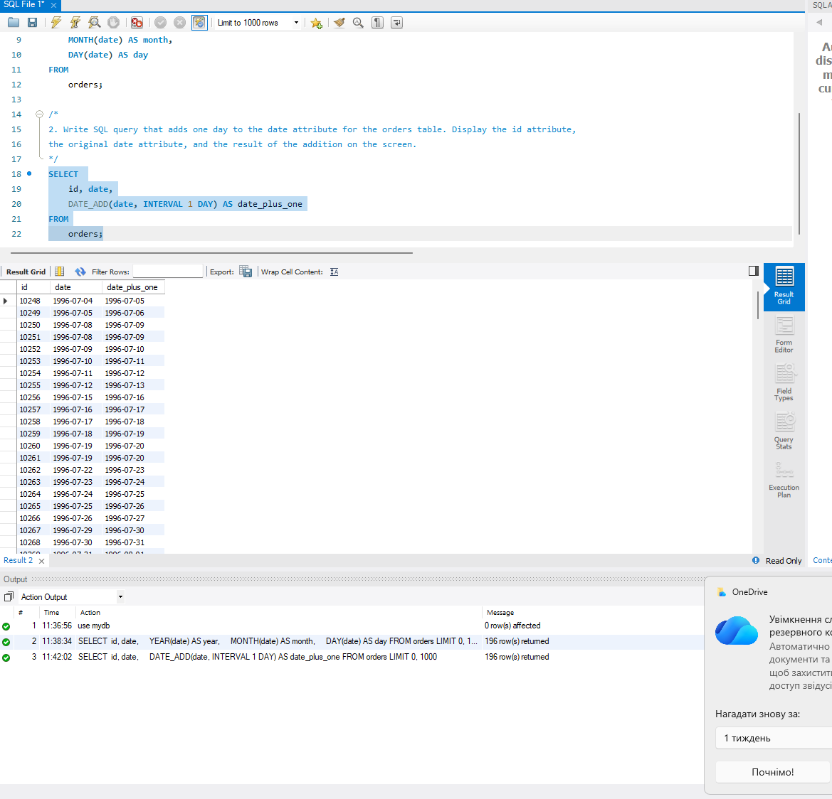
3. Write a SQL query that displays the number of seconds since the epoch (timestamp value) for the date attribute in the orders table. To do this, find and apply the necessary function. Display the id attribute, the original date attribute, and the result of the function on the screen.
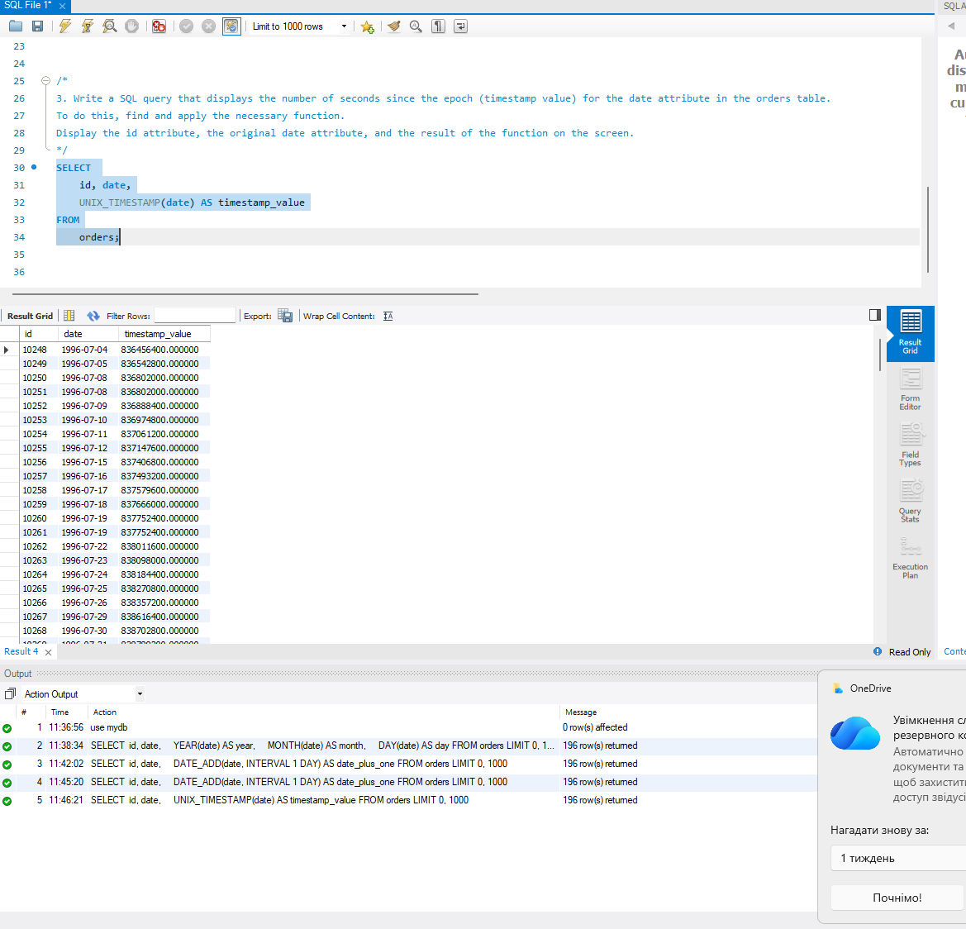
4. Write a SQL query that counts how many rows the order table contains with date attribute falling between 1996-07-10 00:00:00 and 1996-10-08 00:00:00.
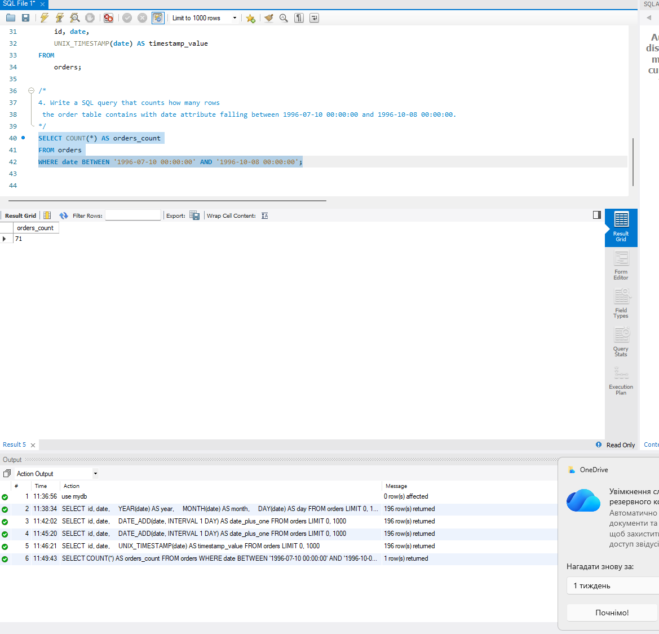
5. Write a SQL query that displays the id attribute , the date attribute and JSON object {“id”: <row id attribute>, “date”: <row date attribute>} from the orders table. Use a function to create the JSON object.
